Java Object-Oriented Programming Experimental Report
NO: Experiment 4 Experiment name：Writing Classes
Student ID | 1607052230 | Name | 邱冠霖 | Class |  | 16软件1班
Location | 实1-314 | Teacher | 唐朝辉 | Time |  | 2018-03-29
1.Experimental purposes and requirements
1.1 Classes and methods
1.2 GUIs: Buttons and Voting with Buttons Textfields
2.Experimental equipment (environment) and requirements
2.1 Eclipse
2.2 Window XP
3.Lab Exercises(Please see Lab Manual)
3.1 A Bank Account Class
3.2 Tracking Grades
3.3 A Band Booster Class(Choose to do)
3.4 Representing Names
3.5 Drawing Squares(Choose to do)
3.6 Voting with Buttons
3.7 Calculating Body Mass Index
4.Experimental results and data processing

5.Analysis and discussion
我把源代码都放在github上，欢迎讨论
https://github.com/kong1414/JavaLesson.git
6.Teacher Reviews  Signature：  Date： |  |  |  |  | Score:

Experimental Report List
1 A Bank Account Class
1) Source code list

package chapter04;
/**
* @Description:
* @Author: QiuGuanLin
* @Date: 2018/3/29 15:19
*/
public class ManageAccounts {
public static void main(String args[]) {
// 创建两个账户
Account acct1, acct2;
//create account1 for Sally with $1000
acct1 = new Account(1000, "Sally", 1111);
//create account2 for Joe with $500
acct2 = new Account(500, "Joe", 2222);
//deposit $100 to Joe's account
acct2.deposit(100.0);
//print Joe's new balance (use getBalance())
System.out.println(acct2.getBalance());
//withdraw $50 from Sally's account
acct1.withdraw(50.0);
//print Sally's new balance (use getBalance())
System.out.println(acct1.getBalance());
//charge fees to both accounts
acct1.chargeFee();
acct2.chargeFee();
//change the name on Joe's account to Joseph
acct2.changeName("Joseph");
//print summary for both accounts
System.out.println();
System.out.println(acct1);
System.out.println(acct2);
}
}

package chapter04;
import java.text.NumberFormat;
/**
* @Description:
* @Author: QiuGuanLin
* @Date: 2018/3/29 15:13
*/
public class Account {
private double balance;
private String name;
private long acctNum;
//----------------------------------------------
//Constructor -- initializes balance, owner, and account number
//----------------------------------------------
public Account(double initBal, String owner, long number) {
balance = initBal;
name = owner;
acctNum = number;
}
//----------------------------------------------
// Checks to see if balance is sufficient for withdrawal.
// If so, decrements balance by amount; if not, prints message.
//----------------------------------------------
public void withdraw(double amount) {
if (balance >= amount) {
balance -= amount;
} else {
System.out.println("Insufficient funds");
}
}
//----------------------------------------------
// Adds deposit amount to balance.
//----------------------------------------------
public void deposit(double amount) {
balance += amount;
}
//----------------------------------------------
// Returns balance.
//----------------------------------------------
public double getBalance() {
return balance;
}
//----------------------------------------------
// Returns a string containing the name, account number, and balance.
//----------------------------------------------
@Override
public String toString() {
NumberFormat fmt = NumberFormat.getCurrencyInstance();
return name + "\t" + acctNum + "\t" + fmt.format(balance);
}
//----------------------------------------------
// Deducts $10 service fee
//----------------------------------------------
public double chargeFee() {
balance -= 10.0;
return balance;
}
//----------------------------------------------
// Changes the name on the account
//----------------------------------------------
public void changeName(String newName) {
name = newName;
}
}

2) Results data processing
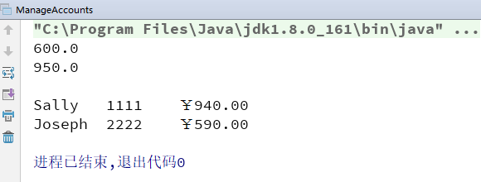

3) Answer questions

4)Error Analysis and Discussion

2 Tracking Grades
1) Source code list

package chapter04;
/**
* @Description:
* @Author: QiuGuanLin
* @Date: 2018/3/29 16:37
*/
public class Grades {
public static void main(String[] args) {
Student student1 = new Student("Mary");
Student student2 = new Student("Mike");
student1.inputGrades();
System.out.println("The average for " + student1.printName() + " is "
+ student1.getAverage() + ".");
student2.inputGrades();
System.out.println("The average for " + student2.printName() + " is "
+ student2.getAverage() + ".");
System.out.println("Student 1: " + student1);
System.out.println("Student 2: " + student2);
}
}

package chapter04;
import java.util.Scanner;
/**
* @Description:
* @Author: QiuGuanLin
* @Date: 2018/3/29 16:35
*/
public class Student {
Scanner scan = new Scanner(System.in);
String name;
double test1, test2;
public Student(String studentName) {
name = studentName;
}
public void inputGrades() {
System.out.print("Please enter the score for test1 and test2:");
test1 = scan.nextDouble();
test2 = scan.nextDouble();
}
public double getAverage() {
return (test1 + test2) / 2;
}
public String printName() {
//add body of printName
return name;
}
@Override
public String toString() {
return name + " test1: " + test1 + " , " + "test2: " + test2 + " .";
}
}

2) Results data processing
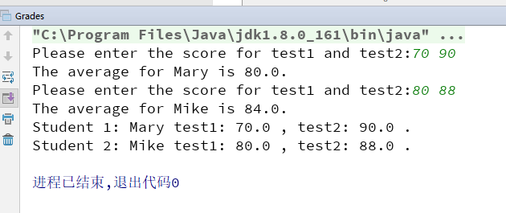

3) Answer questions

4)Error Analysis and Discussion

3 A Band Booster Class(Choose to do)
1) Source code list

2) Results data processing

3) Answer questions

4)Error Analysis and Discussion

4 Representing Names
1) Source code list

package chapter04;
import java.util.Scanner;
/**
* @Description:
* @Author: QiuGuanLin
* @Date: 2018/3/29 18:59
*/
public class TestNames {
public static void main(String args[])
{
Scanner scan = new Scanner(System.in);
Name name1 , name2 ;
String first, middle, last;
System.out.println("Please enter the two person's full name(e.g : first middle last):");
first = scan.next();
middle = scan.next();
last = scan.next();
name1 = new Name(first,middle,last);
first = scan.next();
middle = scan.next();
last = scan.next();
name2 = new Name(first,middle,last);
System.out.println(name1.firstMiddleLast());
System.out.println(name1.lastFirstMiddle());
System.out.println(name1.initials());
System.out.println(name1.length());
System.out.println(name2.firstMiddleLast());
System.out.println(name2.lastFirstMiddle());
System.out.println(name2.initials());
System.out.println(name2.length());
//*************************************
System.out.println(name1.equals(name2.firstMiddleLast()));
}
}

package chapter04;
/**
* @Description:
* @Author: QiuGuanLin
* @Date: 2018/3/29 18:50
*/
public class Name {
private String first, middle, last;
public Name(String first, String middle, String last) {
this.first = first;
this.middle = middle;
this.last = last;
}
/**
* @return 返回first names
*/
public String getFirst() {
return first;
}
/**
* @return 返回middle name
*/
public String getMiddle() {
return middle;
}
/**
* @return 返回 last name
*/
public String getLast() {
return last;
}
/**
* @return 返回一个人的全名，如"Mary Jane Smith"
*/
public String firstMiddleLast() {
return first + " " + middle + " " + last;
}
/**
* @return 返回一个人的全名，先出现last name，如"Smith, Mary Jane"
*/
public String lastFirstMiddle() {
return last + ", " + first + " " + middle;
}
/**
* 如果当前name和otherName一致返回true，要求不区分大小写
* （提示：String对象可以调用equalsIgnoreCase方法，
* 使得两个String比较不区分大小写，如：string1. equalsIgnoreCase(string2)）
*
* @param otherName
* @return
*/
public boolean equals(String otherName) {
String name = first + " " + middle + " " + last;
return name.equalsIgnoreCase(otherName);
}
/**
* 返回人名得缩写（first, middle, 和 last names的首字母，共3个字母），
* 必须全是大写字母（提示：不使用charAt方法，使用substring方法得到字符串的子串，
* 然后调用toUpperCase方法转成大写，详见P77或API文档）
*
* @return 返回人名得缩写
*/
public String initials() {
return first.toUpperCase().substring(0, 1) + middle.toUpperCase().substring(0, 1) + last.toUpperCase().substring(0, 1);
}
/**
* @return 返回人名中的字母数，不含空格
*/
public int length() {
String name = first + middle + last;
return name.length();
}
}

2) Results data processing
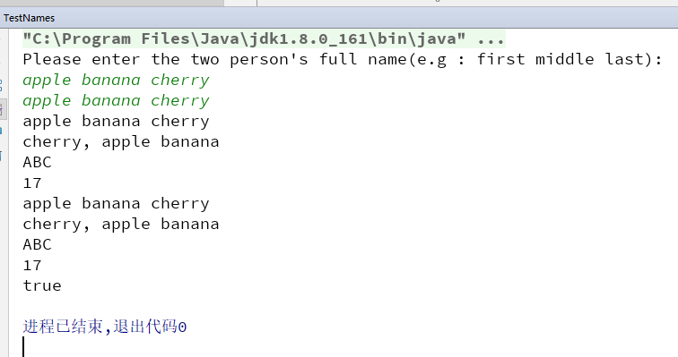

3) Answer questions

4)Error Analysis and Discussion

5 Drawing Squares(Choose to do)
1) Source code list

2) Results data processing

3) Answer questions

4)Error Analysis and Discussion

6 Voting with Buttons
1) Source code list

package chapter04;
import javax.swing.*;
/**
* @Description:
* @Author: QiuGuanLin
* @Date: 2018/3/29 19:06
*/
public class VoteCounter {
//----------------------------------------------
// Creates the main program frame.
//----------------------------------------------
public static void main(String[] args)
{
JFrame frame = new JFrame("Vote Counter");
frame.setDefaultCloseOperation(JFrame.EXIT_ON_CLOSE);
frame.getContentPane().add(new VoteCounterPanel());
// 窗口容器自适应
frame.pack();
frame.setVisible(true);
}
}

package chapter04;
import java.awt.*;
import java.awt.event.*;
import javax.swing.*;
/**
* @Description:
* @Author: QiuGuanLin
* @Date: 2018/3/29 19:06
*/
public class VoteCounterPanel extends JPanel {
private int votesForJoe,votesForSam;
private JButton joe,sam;
private JLabel labelJoe,labelSam;
//----------------------------------------------
// Constructor: Sets up the GUI.
//----------------------------------------------
public VoteCounterPanel()
{
// 投票数
votesForJoe = 0;
joe = new JButton("Vote for Joe");
//对joe这个按钮添加一个事件
joe.addActionListener(new JoeButtonListener());
labelJoe = new JLabel("Votes for Joe: " + votesForJoe);
add(joe);
add(labelJoe);
votesForSam = 0;
sam = new JButton("Vote for Sam");
sam.addActionListener(new SamButtonListener());
labelSam = new JLabel("Votes for Sam: " + votesForSam);
add(sam);
add(labelSam);
setPreferredSize(new Dimension(300, 80));
setBackground(Color.cyan);
}
//***************************************************
// Represents a listener for button push (action) events
//***************************************************
private class JoeButtonListener implements ActionListener
{
//----------------------------------------------
// Updates the counter and label when Vote for Joe
// button is pushed
//----------------------------------------------
@Override
public void actionPerformed(ActionEvent event)
{
votesForJoe++;
labelJoe.setText("Votes for Joe: " + votesForJoe);
}
}
private class SamButtonListener implements ActionListener
{
//----------------------------------------------
// Updates the counter and label when Vote for Sam
// button is pushed
//----------------------------------------------
@Override
public void actionPerformed(ActionEvent event)
{
votesForSam++;
labelSam.setText("Votes for Sam: " + votesForSam);
}
}
}

2) Results data processing
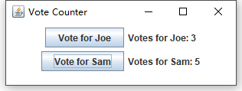

3) Answer questions

4)Error Analysis and Discussion

7 Calculating Body Mass Index
1) Source code list

package chapter04;
import javax.swing.*;
/**
* @Description:
* @Author: QiuGuanLin
* @Date: 2018/3/29 19:23
*/
public class BMI {
public static void main (String[] args)
{
JFrame frame = new JFrame("BMI");
frame.setDefaultCloseOperation(JFrame.EXIT_ON_CLOSE);
BMIPanel panel = new BMIPanel();
frame.getContentPane().add(panel);
frame.pack();
frame.setVisible(true);
}
}

package chapter04;
import javax.swing.*;
import java.awt.*;
import java.awt.event.ActionEvent;
import java.awt.event.ActionListener;
import java.text.DecimalFormat;
/**
* @Description:
* @Author: QiuGuanLin
* @Date: 2018/3/29 19:23
*/
public class BMIPanel extends JPanel {
private int WIDTH = 300;
private int HEIGHT = 120;
private JLabel heightLabel, weightLabel, BMILabel, resultLabel;
private JTextField height, weight;
private JButton calculate;
//-----------------------------------------------------------------
// Sets up the GUI.
//-----------------------------------------------------------------
public BMIPanel()
{
//create labels for the height and weight textfields
heightLabel = new JLabel ("Your height in cm: ");
weightLabel = new JLabel ("Your weight in kg: ");
//create a "this is your BMI" label
BMILabel = new JLabel ("Your BMI is: " );
//create a result label to hold the BMI value
resultLabel = new JLabel ("Your BMI value is: ");
//create a JTextField to hold the person's height in inches
height = new JTextField(5);
//create a JTextField to hold the person's weight in pounds
weight = new JTextField(5);
//create a button to press to calculate BMI
calculate = new JButton("calculate BMI");
//create a BMIListener and make it listen for the button to be pressed
calculate.addActionListener(new BMIListener());
add(Box.createHorizontalStrut(30000));
//add the height label and height textfield to the panel
add(heightLabel);
add(height);
add(Box.createHorizontalStrut(30000));
//add the weight label and weight textfield to the panel
add(weightLabel);
add(weight);
add(Box.createHorizontalStrut(30000));
//add the button to the panel
add(calculate);
add(Box.createHorizontalStrut(30000));
//add the BMI label to the panel
add(BMILabel);
add(Box.createHorizontalStrut(30000));
//add the label that holds the result to the panel
add(resultLabel);
//set the size of the panel to the WIDTH and HEIGHT constants
setPreferredSize(new Dimension(300, 240));
//set the color of the panel to whatever you choose
setBackground(Color.white);
}
private class BMIListener implements ActionListener {
@Override
public void actionPerformed (ActionEvent event)
{
String heightText, weightText;
String value = "";
int heightVal, weightVal;
double bmi;
DecimalFormat fmt = new DecimalFormat("0.#");
//get the text from the height and weight textfields
heightText = height.getText();
weightText = weight.getText();
//Use Integer.parseInt to convert the text to integer values
heightVal = Integer.parseInt(heightText);
weightVal = Integer.parseInt(weightText);
//Calculate the bmi = 703 * weight in pounds / (height in inches)^2
bmi = 10000.0*weightVal / ( heightVal * heightVal ) ;
//Put result in result label. Use Double.toString to convert double to string.
BMILabel.setText("Your BMI is: " + fmt.format(bmi));
if(bmi < 18.5) {
value = "Underweight" ;
} else if( bmi < 24 ) {
value = "Normal range" ;
} else if( bmi < 27 ) {
value = "Overweight " ;
} else if( bmi < 30 ) {
value = "Mild obesity" ;
} else if( bmi < 35 ) {
value = "Moderate obesity" ;
} else {
value = "Severe obesity";
}
resultLabel.setText("Your BMI value is: " + value );
}
}
}

2) Results data processing
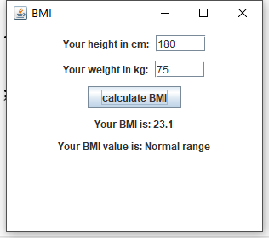

3) Answer questions

4)Error Analysis and Discussion

